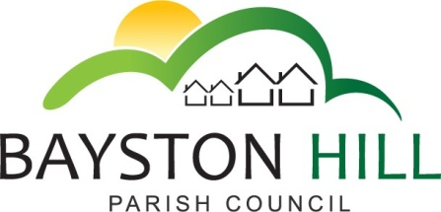

‘protecting and improving the quality of life
for all Bayston Hill residents’

Clerk to the Council/RFO: Caroline Higgins
Chairman: Cllr Fred Jones
31 January 2017

Actions list – Amenities Meetings:

Minute number: | Action: | Action by: | Date for completion: | Status: (Completed; ongoing or outstanding
A54.16 Brookfield Waste Bin | Write to residents of Brookfield re bin position; monitor weekly bin collection by Shropshire Council | Clerk |  | Ongoing
A55.16 a  Long Meadow Play Area | Routine inspections review; keep access clear sign; letter to school | Clerk | March meeting | Agenda item A7.17 (inspections); sign and letter to school outstanding
A55 16 b  Defibrillator | Order and install cabinet; Arrange MOU with Ambulance service;  Arrange training | Clerk | ASAP | Cabinet installed;  MOU and training outstanding
A55.16 c  The Common | Replacement boulders | Cllr Clarke | ASAP | Outstanding
A55.16 d | Plants to be offered to residents; Seek permission to site planters outside Lyth Hill Stores | Clerk | Upon collection of planters;  ASAP | Unable to complete as planters removed without warning;  Permission granted
A56.16 Bus Service Consultation | Letter to Shropshire Council supporting bus services | Clerk | Consultation end date | Completed
FC161.16 1.  Replacement of Cylinder Gang Mower | Purchase rigid deck rotary mower; Sell redundant gang mowers | Clerk/ Cllr Clarke | December | Purchase complete; sale outstanding (prices more favourable in spring)
FC161.16 2. Replacement of Safe | Replace and install new office safe | Clerk | December | Resolved by setting up electronic function (key to be used in emergency only)
FC161.16.3. Long Meadow Maze | Seek 3 quotes and arrange work | Clerk & Cllr Clarke | End of March | Ongoing
J10.16 2. Asset Renewals | Discuss requirements for asset renewals and bring proposals to Full Council | Amenities Committee | February meeting | Agenda item A10.17
J10.16 3. Enhancement of Parish Amenities | Prepare funding bid to improve facilities; Attend Energize convention | Cllrs Candy and Keel in conjunction with the Clerk | January / February 2017 | Ongoing – agenda item A8.17

